**Problem 1,2**

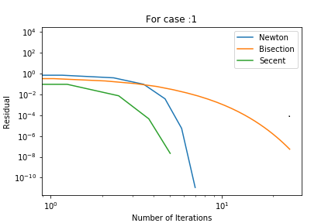 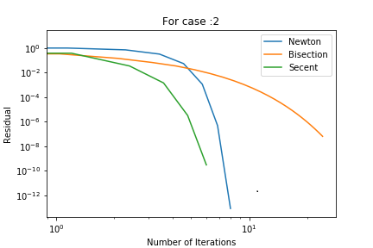

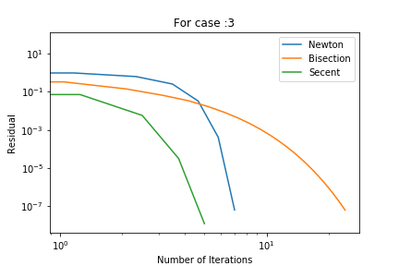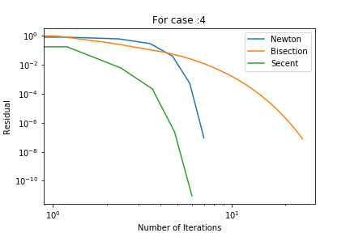

**Pressure by Bisection Method**

Bisection Pressure :0.303254

Bisection Pressure :461.545

Bisection Pressure :46.1601

Bisection Pressure :1691.65

**Pressure by Newton Method**

Newton Pressure :0.303254

Newton Pressure :461.545

Newton Pressure :46.1601

Newton Pressure :1691.65

**Pressure by Secant Method**

Secant Pressure :0.303254

Secant Pressure :461.545

Secant Pressure :46.1601

Secant Pressure :1691.65

The pressure converges to same value for all the test cases. From the rate of convergence table it seems that newton is the fastest, but from the graphs it seems secant converge faster than other method.

**Problem 3**

Convergence Rate for Different Methods

